

**PROTOCOL**for laboratory exercise

***Router introduction***

|  |  |  |
| --- | --- | --- |
| Group / Class | Secretary | Signature |
| 5 / **3BHEL** | **HOFSTÄTTER A.** |  |
| Exercise- / Delivery date | Employee | Signature |
| 7. Nov. 2013  14. Nov. 2013 | **HIRSCH L.** |  |
| Teacher | Employee | Signature |
| GRUBER |  |  |
| Grade | Employee | Signature |
|  |  |  |
| ***Router introduction***  ***Cisco 2514*** | | |
| **Used Devices**   |  |  |  |  |  | | --- | --- | --- | --- | --- | | Nr. | Device | Manufacturer | Type | Place Nr. | | 1. | **Router** | **Cisco** | **2514** | - |   **Used Programs**   |  |  |  | | --- | --- | --- | | Nr. | Name | Version | | 1. | **Hyper Terminal** | **-** | | 2. | **Putty** | **-** | | | |

ÜBUNGS-/ABGABE-DATUM

Klasse /Gruppe

NOTE

LEHRER

# Contents

1 Contents 2

2 Tasks 3

2.1 Network 3

2.1.1 **DCE** - IP Configurations: 3

2.1.2 **DTE** - IP Configurations: 3

3 Basic Router Configuration - R1 4

3.1 Change Hostname (optional) 4

3.2 Disable Domain Lookup (optional) 4

3.3 Synchronizing Log Messages (optional) 4

4 Configure Interfaces 4

4.1 Ethernet0 4

4.2 Serial0 (R4 – R1) 5

4.3 Serial1 (R1 – R2) 5

5 Setup a Routing Protocol 5

6 Testing and Debugging 6

6.1 Ping command Host/Router 6

6.2 Show commands 6

6.2.1 Show IP Route 6

6.2.2 Show Protocols 7

6.2.3 Show IP Protocols 7

# Tasks

In this laboratory exercise a loop of 4 routers should be configured. Every router was connected via serial interfaces to the other routers. Everyone of theese 4 routers had its own LAN. At the end every LAN and every Router should be reachable from every LAN or Router.

So to every router two routes are available, that’s because it’s a loop.

Note: The following steps describe how to configure Router R1. For a working network the other Routers R2, R3 and R4 need a valid and working configuration which were programmed by other groups.

## Network

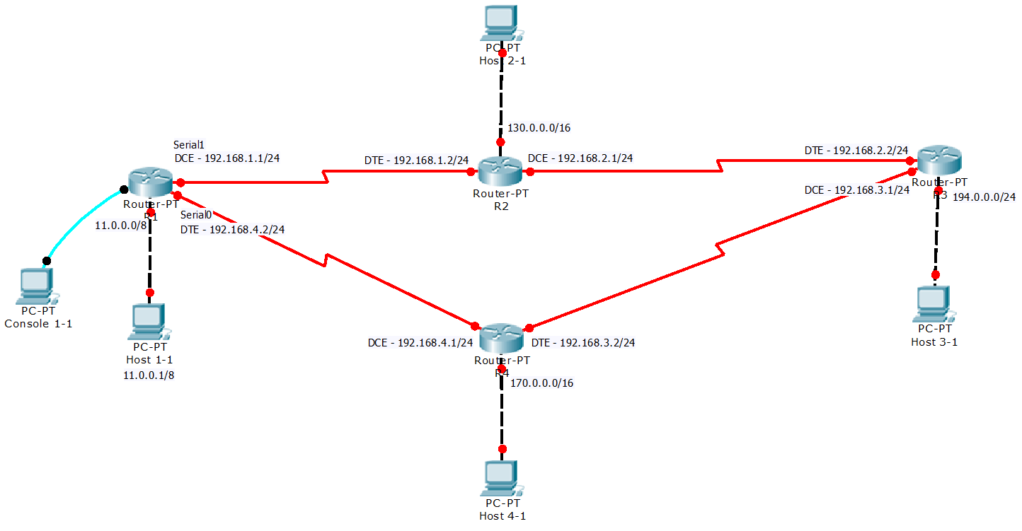

Figure 1 - Network Topology

As showed as above all 4 routers were connected via serial connections. Between the routers Class C Networks with a 24 bit Subnetmask were used.

|  |  |  |  |
| --- | --- | --- | --- |
| 192.168.1.0/24 | 192.168.2.0/24 | 192.168.3.0/24 | 192.168.4.0/24 |
| Serial: R1 – R2 | Serial: R2 – R3 | Serial: R3 – R4 | Serial: R4 – R5 |

Thereby a serial connection needs a DCE (Data Communication Equipment) and a DTE (Date Terminating Equipment) site the following configuration was selected. Every DCE Serial interface got the first DTE the second Host Address in the network:

|  |  |
| --- | --- |
| **DCE** - IP Configurations:  * R1 - 192.168**.1.1**/24 * R2 - 192.168.**2.1**/24 * R3 - 192.168.**3.1**/24 * R4 - 192.168.**4.1**/24 | **DTE** - IP Configurations:  * R1 - 192.168.**1.2**/24 * R2 - 192.168.**2.2**/24 * R3 - 192.168.**3.2**/24 * R4 - 192.168.**4.2**/24 |

The clock rate need to be set on the serial interface which is connected with the DCE site of the cable.

# Basic Router Configuration - R1

After the first boot the router asks to continue with a configuration dialog. This was aborted whit no.

Continue with configuration dialog? [yes/no]: **no**

At first the PC was connected via a RS-232 cable to the Router. As terminal emulation program HyperTerminal on Windows XP was used. The baud rate was set to 9600 bauds.

## Change Hostname (optional)

The hostname in the lab network was changed from the default (**Router**) to **R1**.

Router>

Router>enable

Router#configure terminal

Router(config)#**hostname R1**

R1(config)#

## Disable Domain Lookup (optional)

By default, when a command in user or enable mode is entered into a router and this command is not recognized, the router believes that this is the host name of a device that the user is attempting to reach using telnet. Therefore, the router tries to resolve the unrecognized command into an IP address by doing an IP domain lookup. If no specific domain server has been configured on the router, the router will issue a broadcast for the command to be translated into an IP address. It can take several seconds for the router prompt to return while the router waits for a response to its Domain Name System (DNS) broadcast.

R1>enable - Enter privileged EXEC mode

R1#configure terminal - Enter global configuration mode

R1(config)#**no ip domain lookup** - disable domain lookup

## Synchronizing Log Messages (optional)

This is very useful to synchronize system messages with the command prompt. By default the router displays a system message at every time no matter whether you are typing or not.

R1>enable

R1#configure terminal

R1(config)#line con 0 - Specify the line to be configured

R1(config-line)#logging synchronous- Enable synchronous logging of messages.

# Configure Interfaces

## Ethernet0

This Ethernet port was used to connect a Host to the R1 (11.0.0.0/8).

R1>enable

R1#configure terminal

R1(config)#interface Ethernet0 - Configure interface Ethernet0

R1(config-if)#ip address 11.0.0.1 255.255.255.0 - Set IP and SNM

R1(config-if)#no shutdown - Enable interface

The following settings for the Host-PC on port Ethernet0 was set.

|  |  |  |
| --- | --- | --- |
| **IP Address:** |  | 11.0.0.2 |
| **Subnetmask:** |  | 255.255.255.0 |
| **Default Gateway:** |  | 11.0.0.1 |

## Serial0 (R4 – R1)

This Serial port was used to connect Router R4 (**DCE**) to Router R1 (**DTE**). The clock rate was set on Router R4.

R1>enable

R1#configure terminal

R1(config)#**interface Serial0**  - Configure interface Serial0

R1(config-if)#**ip address 192.168.4.2 255.255.255.0**

R1(config-if)#no shutdown

## Serial1 (R1 – R2)

This Serial port was used to connect Router R1 (**DCE**) to Router R2 (**DTE**). In this scenario the connections required a clockrate which need to be set on R1.

R1>enable

R1#configure terminal

R1(config)#interface Serial1 - Configure interface Serial0

R1(config-if)#ip address 192.168.1.1 255.255.255.0

R1(config-if)#clock rate 125000 - Set clock rate to 125 kbit/s

R1(config-if)#no shutdown

# Setup a Routing Protocol

In this network we use RIP(v1) as Routing protocol. It is easy to setup and use. Also it is good for small networks.

R1>enable

R1#configure terminal

R1(config)#**router rip** - Configure RIP (v1)

R1(config-router)#**network 11.0.0.0 255.255.255.0** - Add network (Ethernet0)

R1(config-router)#network 192.168.4.0 255.255.255.0 - Add network (Serial0)

R1(config-router)#network 192.168.1.0 255.255.255.0 - Add network (Serial1)

Now RIP listens and updates the networks listed above.

The RIP protocol sends the routing table every 30 seconds to all given networks.

# Testing and Debugging

All Routers are now connected and configured with RIP and all RIP-Tables are up-to-date that means the network is converged.

## Ping command Host/Router

* Host1 (11.0.0.2) can ping 11.0.0.1 (R1 Ethernet0 – Gateway)
* Host1 (11.0.0.2) can ping 192.168.4.2 (R1 Serial0)
* Host1 (11.0.0.2) can ping 192.168.1.1 (R1 Serial1)
* Host1 can ping every Serial Interface of every router.
* Host H1 can ping all Serial Interfaces and all LANs on every router.
* Router R1 can ping all Serial Interfaces and all LANs on every router.

## Show commands

The following show commands are all entered in the user EXEC mode.

### Show IP Route

R1#**show ip route**

Codes: I - IGRP derived, **R - RIP derived**, O - OSPF derived,

**C - connected**, S - static, E - EGP derived, B - BGP derived,

* - candidate default route, IA - OSPF inter area route,

i - IS-IS derived, ia - IS-IS, U - per-user static route,

o - on-demand routing, M - mobile, P - periodic downloaded static route,

D - EIGRP, EX - EIGRP external, E1 - OSPF external type 1 route,

E2 - OSPF external type 2 route, N1 - OSPF NSSA external type 1 route,

N2 - OSPF NSSA external type 2 route

Gateway of last resort is not set - no default route

**R** 170.0.0.0/16 [120/1] via 192.168.4.1, Serial0 - Learned via RIP

**C** 192.168.4.0/24 is directly connected, Serial0 - Directly connected

**R** 130.0.0.0/16 [120/1] via 192.168.1.2, Serial1 - Learned via RIP

**C** 11.0.0.0/8 is directly connected, Ethernet0 - Directly connected

**C** 192.168.1.0/24 is directly connected, Serial1 - Directly connected

**R** 194.0.0.0/24 [120/2] via 192.168.1.2, Serial1 - Learned via RIP

[120/2] via 192.168.4.1, Serial0 - Learned via RIP

**R** 192.168.2.0/24 [120/1] via 192.168.1.2, Serial1 - Learned via RIP

**R** 192.168.3.0/24 [120/1] via 192.168.4.1, Serial0 - Learned via RIP

In this table you see the routes on which a net can be reached. This depends on two factors: Number of Hops (Metric) and Administrative Distance. If both factors are the same there are two routes available.

So as you see above there are two routes with the same number of hops to the LAN of R3, therefore a net is reachable via two ways. This could be useful for redundancy or load balancing.

### Show Protocols

R2#**show protocols**

Global values:

Internet Protocol routing is enabled

FastEthernet0 is up, line protocol is up

Internet address is 11.0.0.0/8

FastEthernet1 is administratively down, line protocol is down

Serial0 is up, line protocol is up

Internet address is 192.168.4.0/24

Serial1 is up, line protocol is up

Internet address is 192.168.1.0/24

Above all interfaces with their actual status are shown. If they are up the configured IP Address and Subnetmask are shown.

### Show IP Protocols

R1#**show ip protocols**

Routing Protocol is "rip"

Sending updates every 30 seconds, next due in 20 seconds

Invalid after 180 seconds, hold down 180, flushed after 240

Outgoing update filter list for all interfaces is not set

Incoming update filter list for all interfaces is not set

Redistributing: rip

Default version control: send version 1, receive version 1

Interface Send Recv Key-chain

Ethernet0 1 1

Serial0 1 1

Serial1 1 1

Routing for Networks:

11.0.0.0

192.168.1.0

192.168.4.0

Routing Information Sources:

Gateway Distance Last Update

192.168.4.1 120 00:00:06

192.168.1.2 120 00:00:13

Distance: (default is 120)

This shows the actual information for the active routing protocols (RIPv1).